# Iterative Flux Site Plan

## Mark Rowley

## WDD 130

## Overview

### Purpose

Provide a dynamic and easy-to-view portfolio of various projects [I] have completed, as well as showcase my current project and the progress I’ve made on it since I began.

### Audience

The main audience is recruiter, potential employers, peers in the industry, and any clients I work with.

## Branding

### Website Logo

 {Copilot}

## Style Guide

### Color Palette

|  |  |  |  |
| --- | --- | --- | --- |
| **Primary** | **Secondary** | **Accent 1** | **Accent 2** |
| #2C2E5A | #4A4F63 | #3FD6D9 | #D94F9F |

### Typography

#### Heading Font: Playfair Display (Serif)

#### Paragraph Font: Lato (Sans Serif)

### Navigation

Home Technical Projects Creative Works

**Content**

[put all content for the pages here, including written text and images]

### Home

“Iteration is the hardest and most rewarding step in innovation”



{[Colorful JavaScript Code on Computer Screen; Rashed Paykary, Pexels](https://www.pexels.com/photo/colorful-javascript-code-on-computer-screen-29445973/)}

{[document, paper, writing, page, text, ink, book, poetry; ??, Pixnio](https://pixnio.com/objects/books/document-paper-writing-page-text-ink-book-poetry#img_info)}

{[Robot Pointing on a Wall; Tara Winstead, Pexels](https://www.pexels.com/photo/robot-pointing-on-a-wall-8386440/)}

{[Orchestra Vibrations 6; omar sahel, Public Domain Pictures](https://www.publicdomainpictures.net/en/view-image.php?image=631159&picture=orchestra-vibrations-6)}

A living archive of various projects I have worked on over the years. Each project summarized and shared here is not just another example of my work, but a record of my journey as I’ve grown and learned over the years. The site embodies the philosophy that learning happens through iteration, and every cycle leaves a lasting mark.

Neon Veil {Current Project}  
Tags: Branching Storytelling, Pixel Art, Adaptive AI Behavior

Neon Veil is a narrative‑driven indie game prototype set in a cyber‑mystic city where players uncover hidden layers of reality through exploration and choice. The project experiments with modular dialogue systems, branching storylines, and atmospheric art direction. It’s designed as a sandbox for testing narrative mechanics and visual identity in a game context.{ Progress



{Copilot}

# Technical Projects

Pipeline Synthesizer

Skills: React Architecture, Firebase, Pipeline Modeling, Data Visualization

A scalable React + Firebase dashboard that visualizes asset flow across animation and game pipelines. Tracks versioning, reuse, and legacy markers across projects, enabling long‑term studio visibility and modular reuse.

Completed: 2026 – 09 – 13

Project Duration: 73 Hours

Modular Dialogue Engine

Skills: Node.js, Express, JSON Parsing & Validtaion, Rendering Logic

A Node.js tool that parses branching dialogue trees from JSON files and renders them in a simple web interface. Built to test modularity, pacing, and adaptive narrative logic for future game or story systems.

Completed: 2026 – 07 – 02

Project Duration: 37 Hours

Glyph (Image Sorter)

Skills: Python, Regex Pattern Matching, File I/O, Image Recognition

A lightweight Python script that scans a folder of image assets, detects naming patterns, and auto‑sorts them into subfolders based on glyph type (e.g., UI, lore, combat). Designed to streamline asset organization for creative pipelines.

Completed: 2026 – 04 – 27

Project Duration: 14 Hours

### Creative Projects



## Digital Art

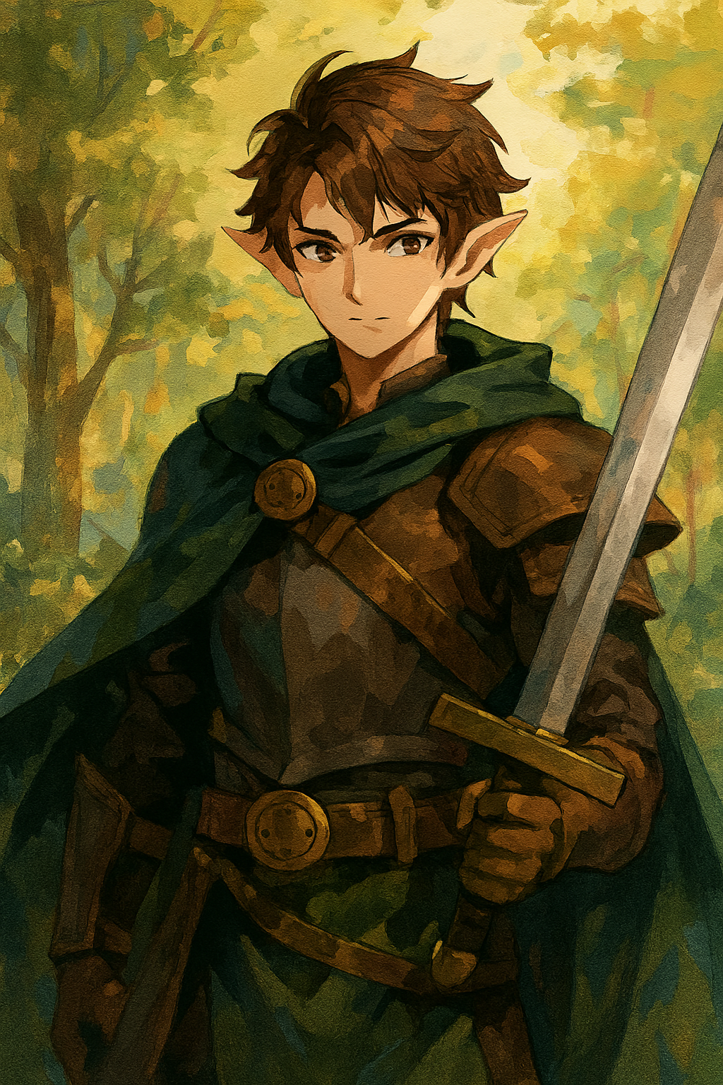

## Books

The Lantern Beneath the Lake

Genre: Gothic Fantasy

When a drought reveals a submerged village beneath a forgotten lake, a grieving historian discovers a lantern that reveals the past unseen. As she follows its glow, she uncovers a buried kingdom hidden between the living and the drowned.

Thread Logic

Genre: Science Fiction Mystery

In a future where thoughts are stitched into wearable fabrics, a rogue archivist unravels a thread that shouldn’t exist — one that drops him in the middle of a secret murderers’ machinations.

The Orchid that Ate the Moon

Genre: Surreal Fantasy

A boy plants a seed that grows into a glittering orchid. Each night, the moon shrinks in size, and in his dreams, the flower speaks of the wishes the moon never answered.

A Crowns Hollow Promise

Genre: Political Fantasy

In a realm where rulers are bound by magical contracts, a scribe discovers a coupe set in motion by another vindictive scribe. He must stop the coupe, or the entire order of the kingdoms could fall apart.

## Games

Signal Drift

Skills: Puzzle Logic, Environmental Storytelling, Open-World Exploration

Signal Drift is an exploration game set in a decaying digital city where players navigate signal towers, decode corrupted transmissions, and uncover fragments of a lost network. The game experiments with ambient storytelling, glitch aesthetics, and modular signal puzzles. Designed as a prototype for testing pacing, atmosphere, and non-verbal narrative delivery.



{[Neon Dreamscape; codenighter, DeviantArt](https://www.deviantart.com/codenighter/art/Neon-Dreamscape-1015096492)}

### Footer

Contact Me

[Seriousemail123@gmail.com](mailto:Seriousemail123@gmail.com)

[Instagram](https://www.instagram.com/)

[Facebook](https://www.facebook.com/)

[Pinterest](https://www.pinterest.com/)

**Wireframes**

### Home Page Wireframe

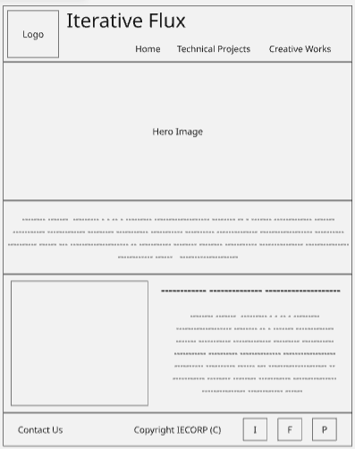

### Technical Projects Wireframe

### Creative Works Wireframe

